**Details of your portfolio**

PD URL site *(*Compulsory to fill up for milestone 2 and 3):*

**https://porfoliodev-production.up.railway.app/**

Name of your portfolio:

Where Developers  
Meets Designer

*Lim Xing Herng*

Your Logo:

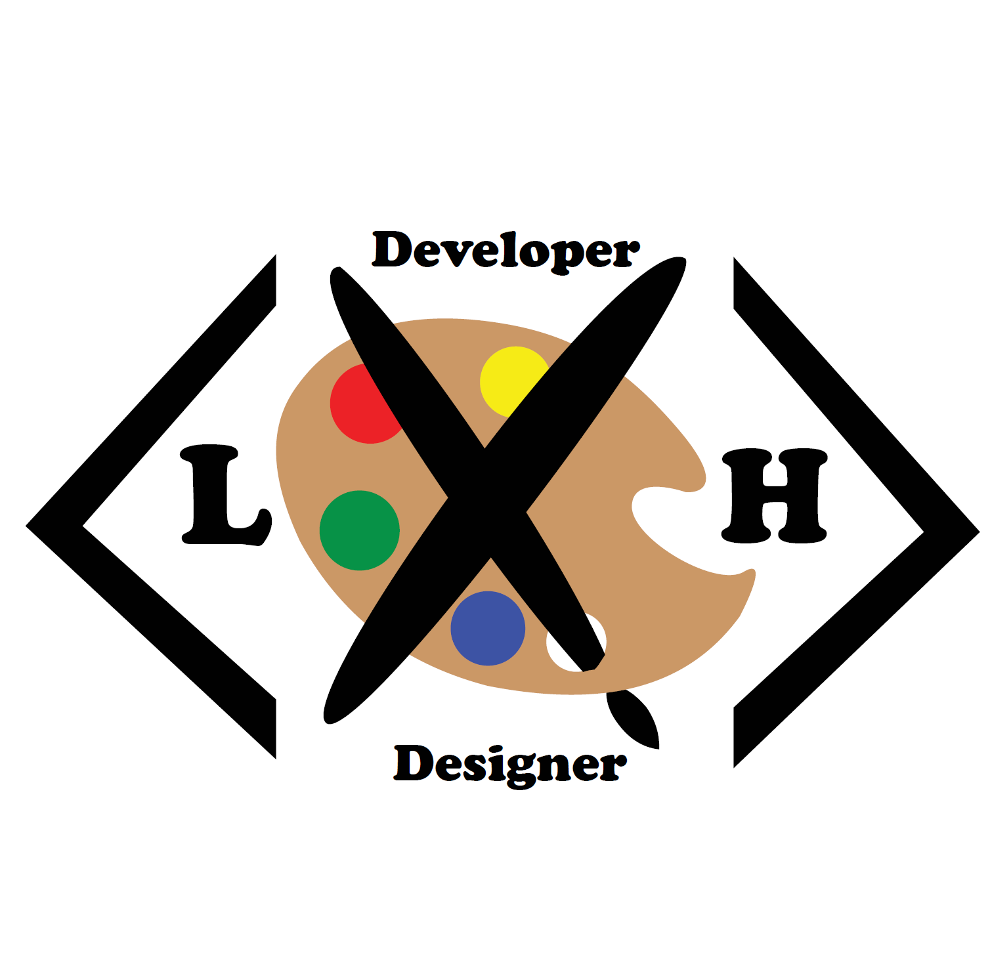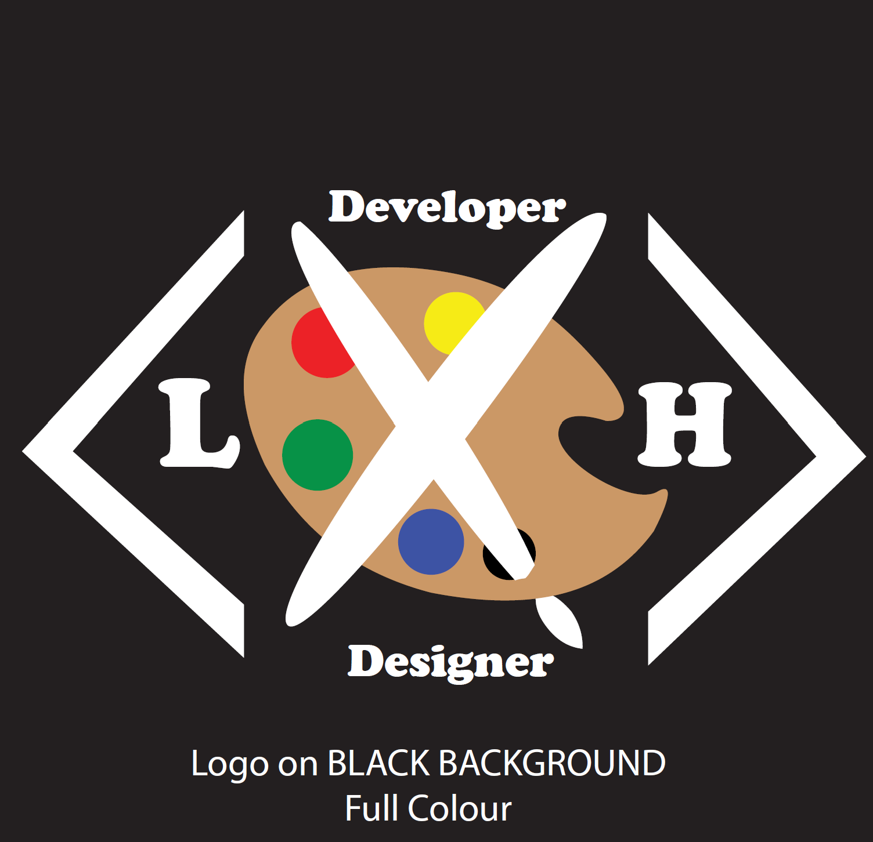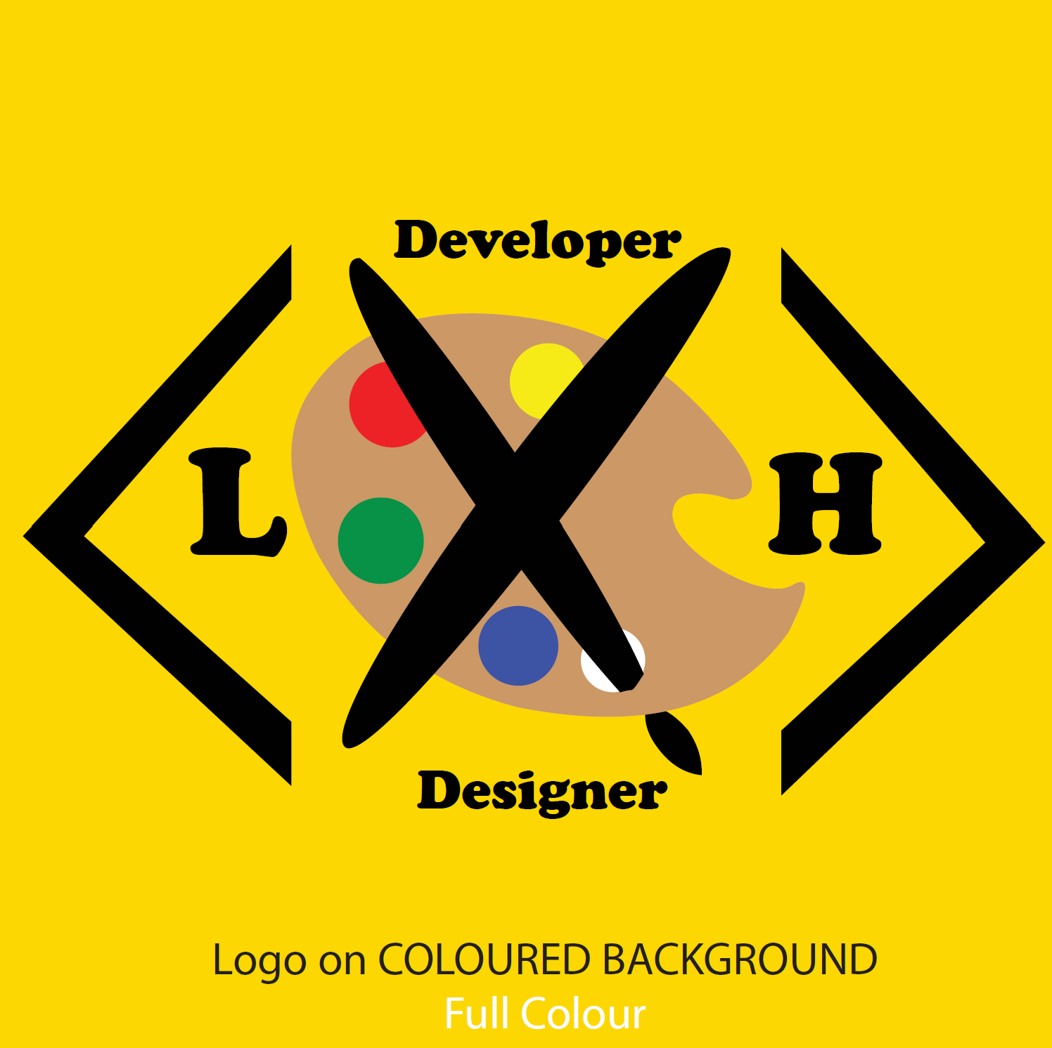

Describe your target audience:

*My portfolio is designed for the following audiences:*

* *Recruiters looking for frontend or UI/UX(I just put this in since we are going to learn UI/UX next sem) designer*
* *Job recruiters who are seeking people who are seeking creative and technical collaboration*
* *Collaborators in digital design development fields*

Describe your brand story/ purpose:

*Theme : Where Designer Meets Developer*

*The theme I am going for in my portfolio this showcasing the balance between bring a developer and a designer. I wanted to keep the overall style clean and minimal to make it easy to navigate around.*

*I used blue tones to represent my coding/development side and pink/purple was used to represent design. I used the colours in my digital banner as well ass throughout my pages to reinforce that dual identity*

*I also tried to use round elements and gradient to keep things modern and soft, While making work more readable through fonts.*

*Overall the theme reflects my ideal identity: someone who enjoys blending logic and creativity, building both functional and visually pleasing work.*

**Design brief**

Colour scheme & Colour palette:

*Color Scheme: Split- Complementary*

*Reasoning:*

*I went with a split-complementary color scheme using blue and pink/purple tones. The blue shows the developer side of me — more logical and structured — while the pink and purple bring out the creative, design side. These colors give enough contrast to make both sides stand out, but not in a way that feels too loud or clashing. The contrast is softer and easier on the eyes compared to a full complementary color combo. I also used light grey in the background to keep everything clean, simple, and easy to read — which matches the calm, minimal vibe I wanted for the whole portfolio.*

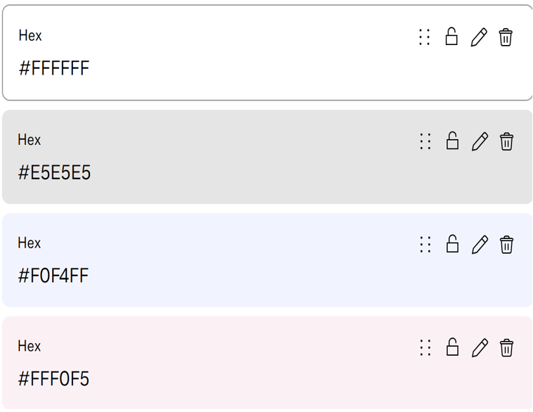

Typography:

*Headers – Impact*

*I chose impact as it commands attention which is great for titles.*

*Body Text – Calibri Light*

*Balances out the strength of impact with a softer and more readable tone.*

*Code Snippets- Courier New*

*Signals contents clearly good to use for skills ,syntax or command lines.*

Theme:

*Minimalist.*

Layout/ Arrangement:

*How will you arrange the multimodal composition in a way that makes sense for your audience and your purpose? How might you arrange ideas and elements so that your composition is effective?*

***Minimally 3 tabs with 2 layers of navigation***

Opening page

Home

About

Contact

Portfolio

Development

Design

**Low fidelity wireframe:**

*Insert your low-fidelity wireframe here. This can be photo of your sketches or digitally created low-fidelity wireframe using shapes. E.g.*

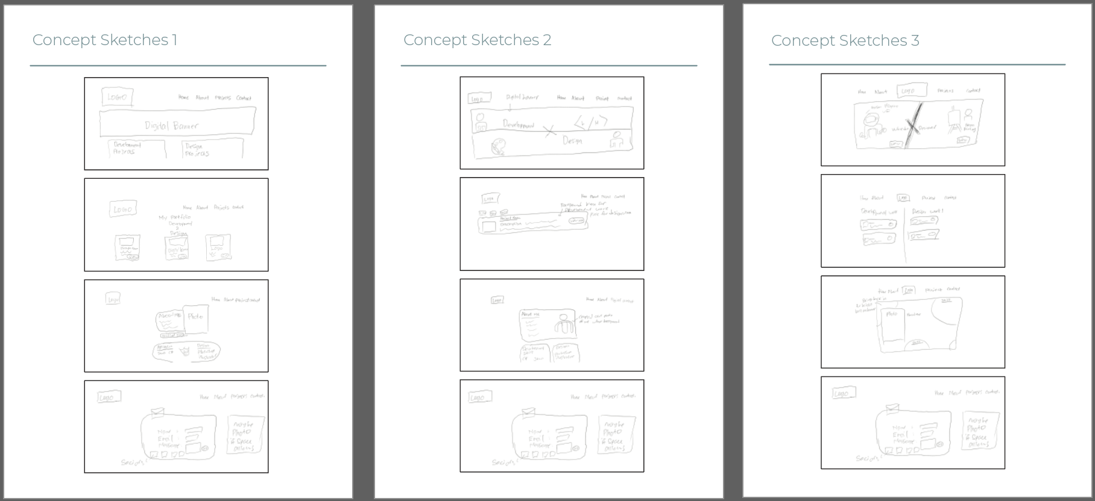

**High fidelity wireframe** *(*Compulsory to fill up for milestone 2 and 3)***:**

*Insert your high-fidelity wireframe here. Full set of ALL the pages in JPEG or PDF format.*

*E.g.*

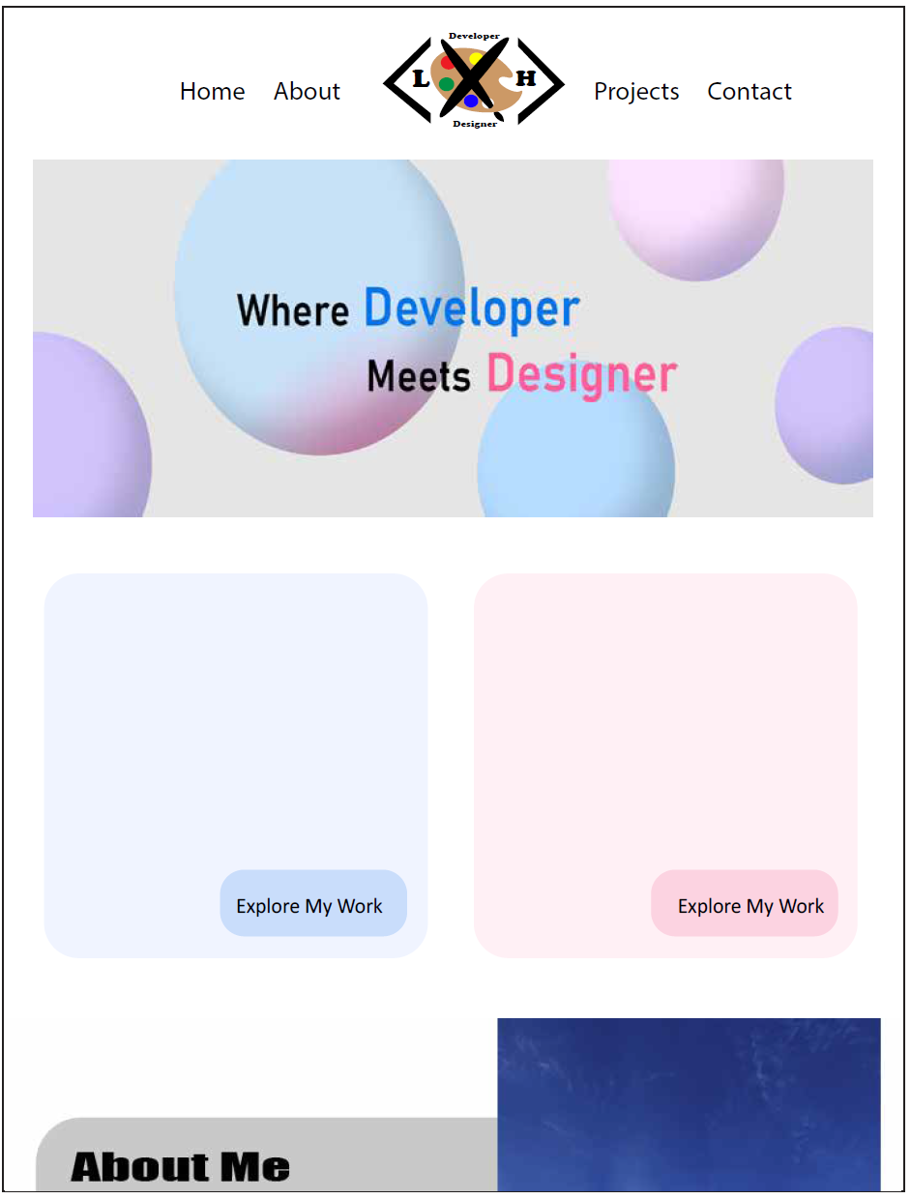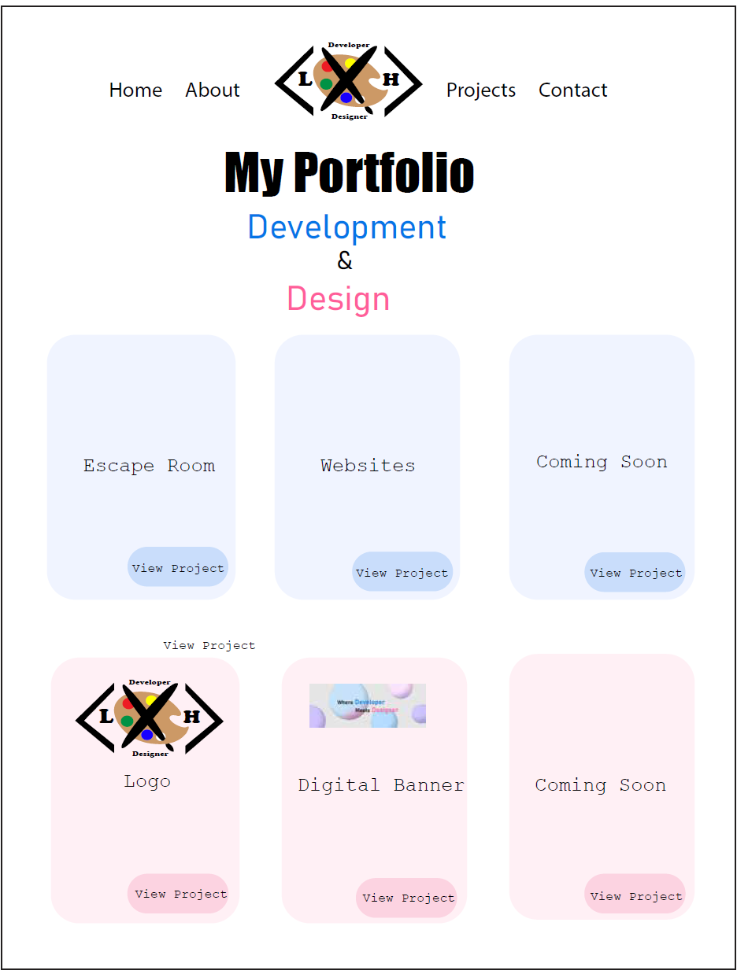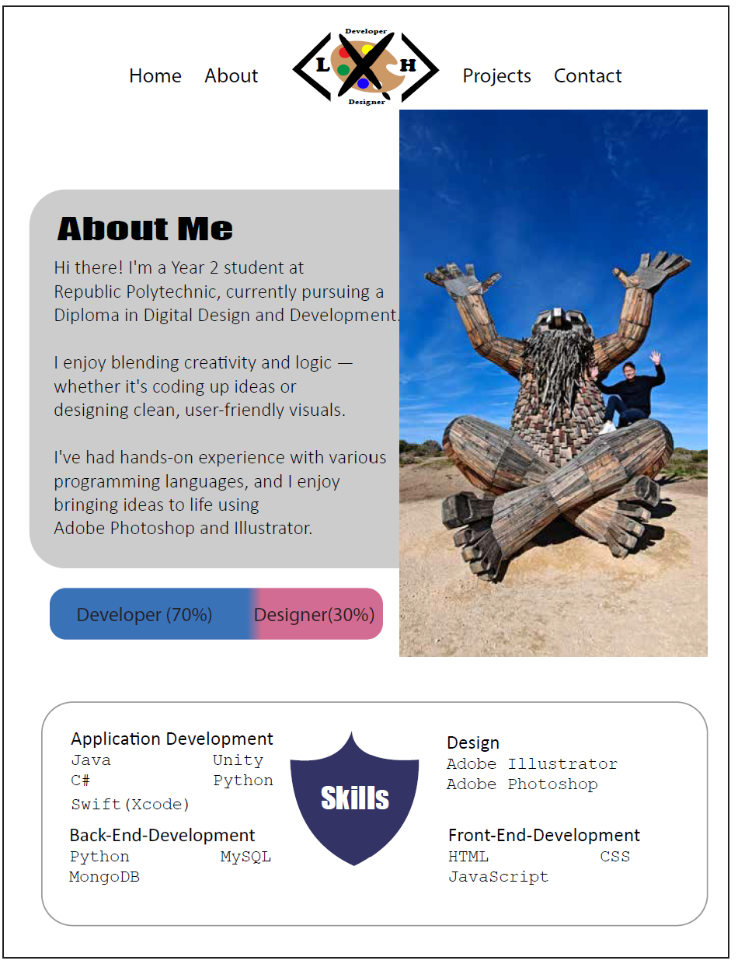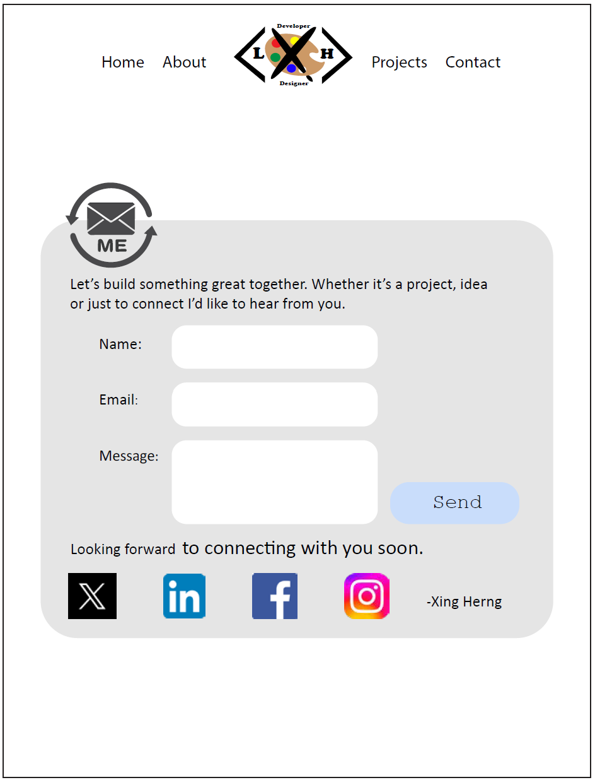

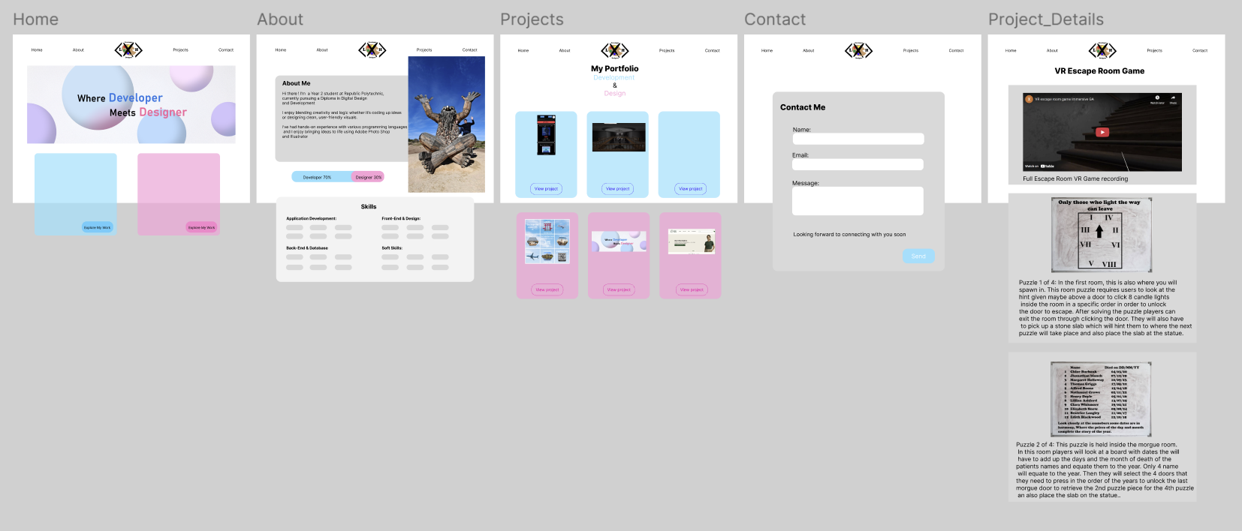

**Link to your Prototype – Most likely on Figma (make sure your lecturer is given access to the site)** *(To fill up for milestone 2 and 3)***:**

[**https://www.figma.com/design/YetiLez2WCDzMFiwqISVL9/Portfolio_Design-High-Low-Fidelity?node-id=0-1&t=qt7YGgQV3r7HEiJ3-1**](https://www.figma.com/design/YetiLez2WCDzMFiwqISVL9/Portfolio_Design-High-Low-Fidelity?node-id=0-1&t=qt7YGgQV3r7HEiJ3-1)

**Home Page:**

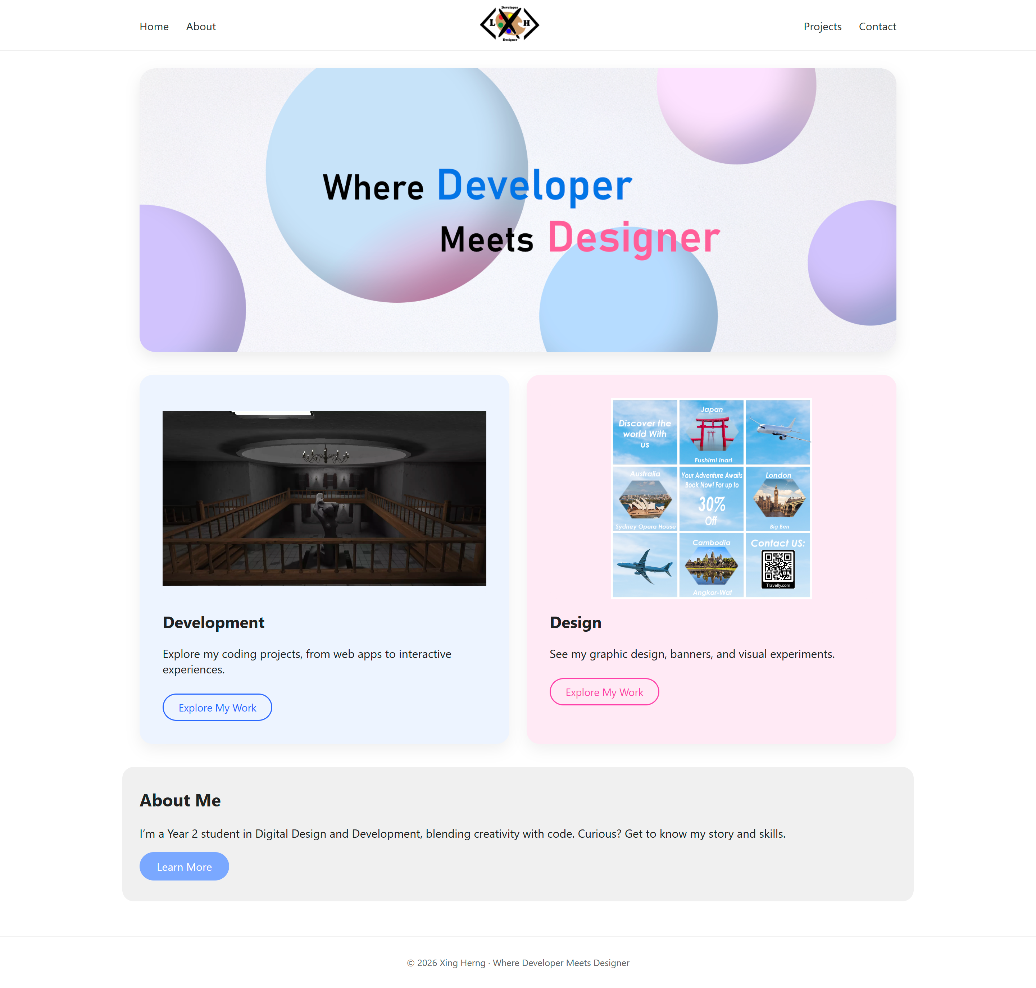

**About Me Page:**

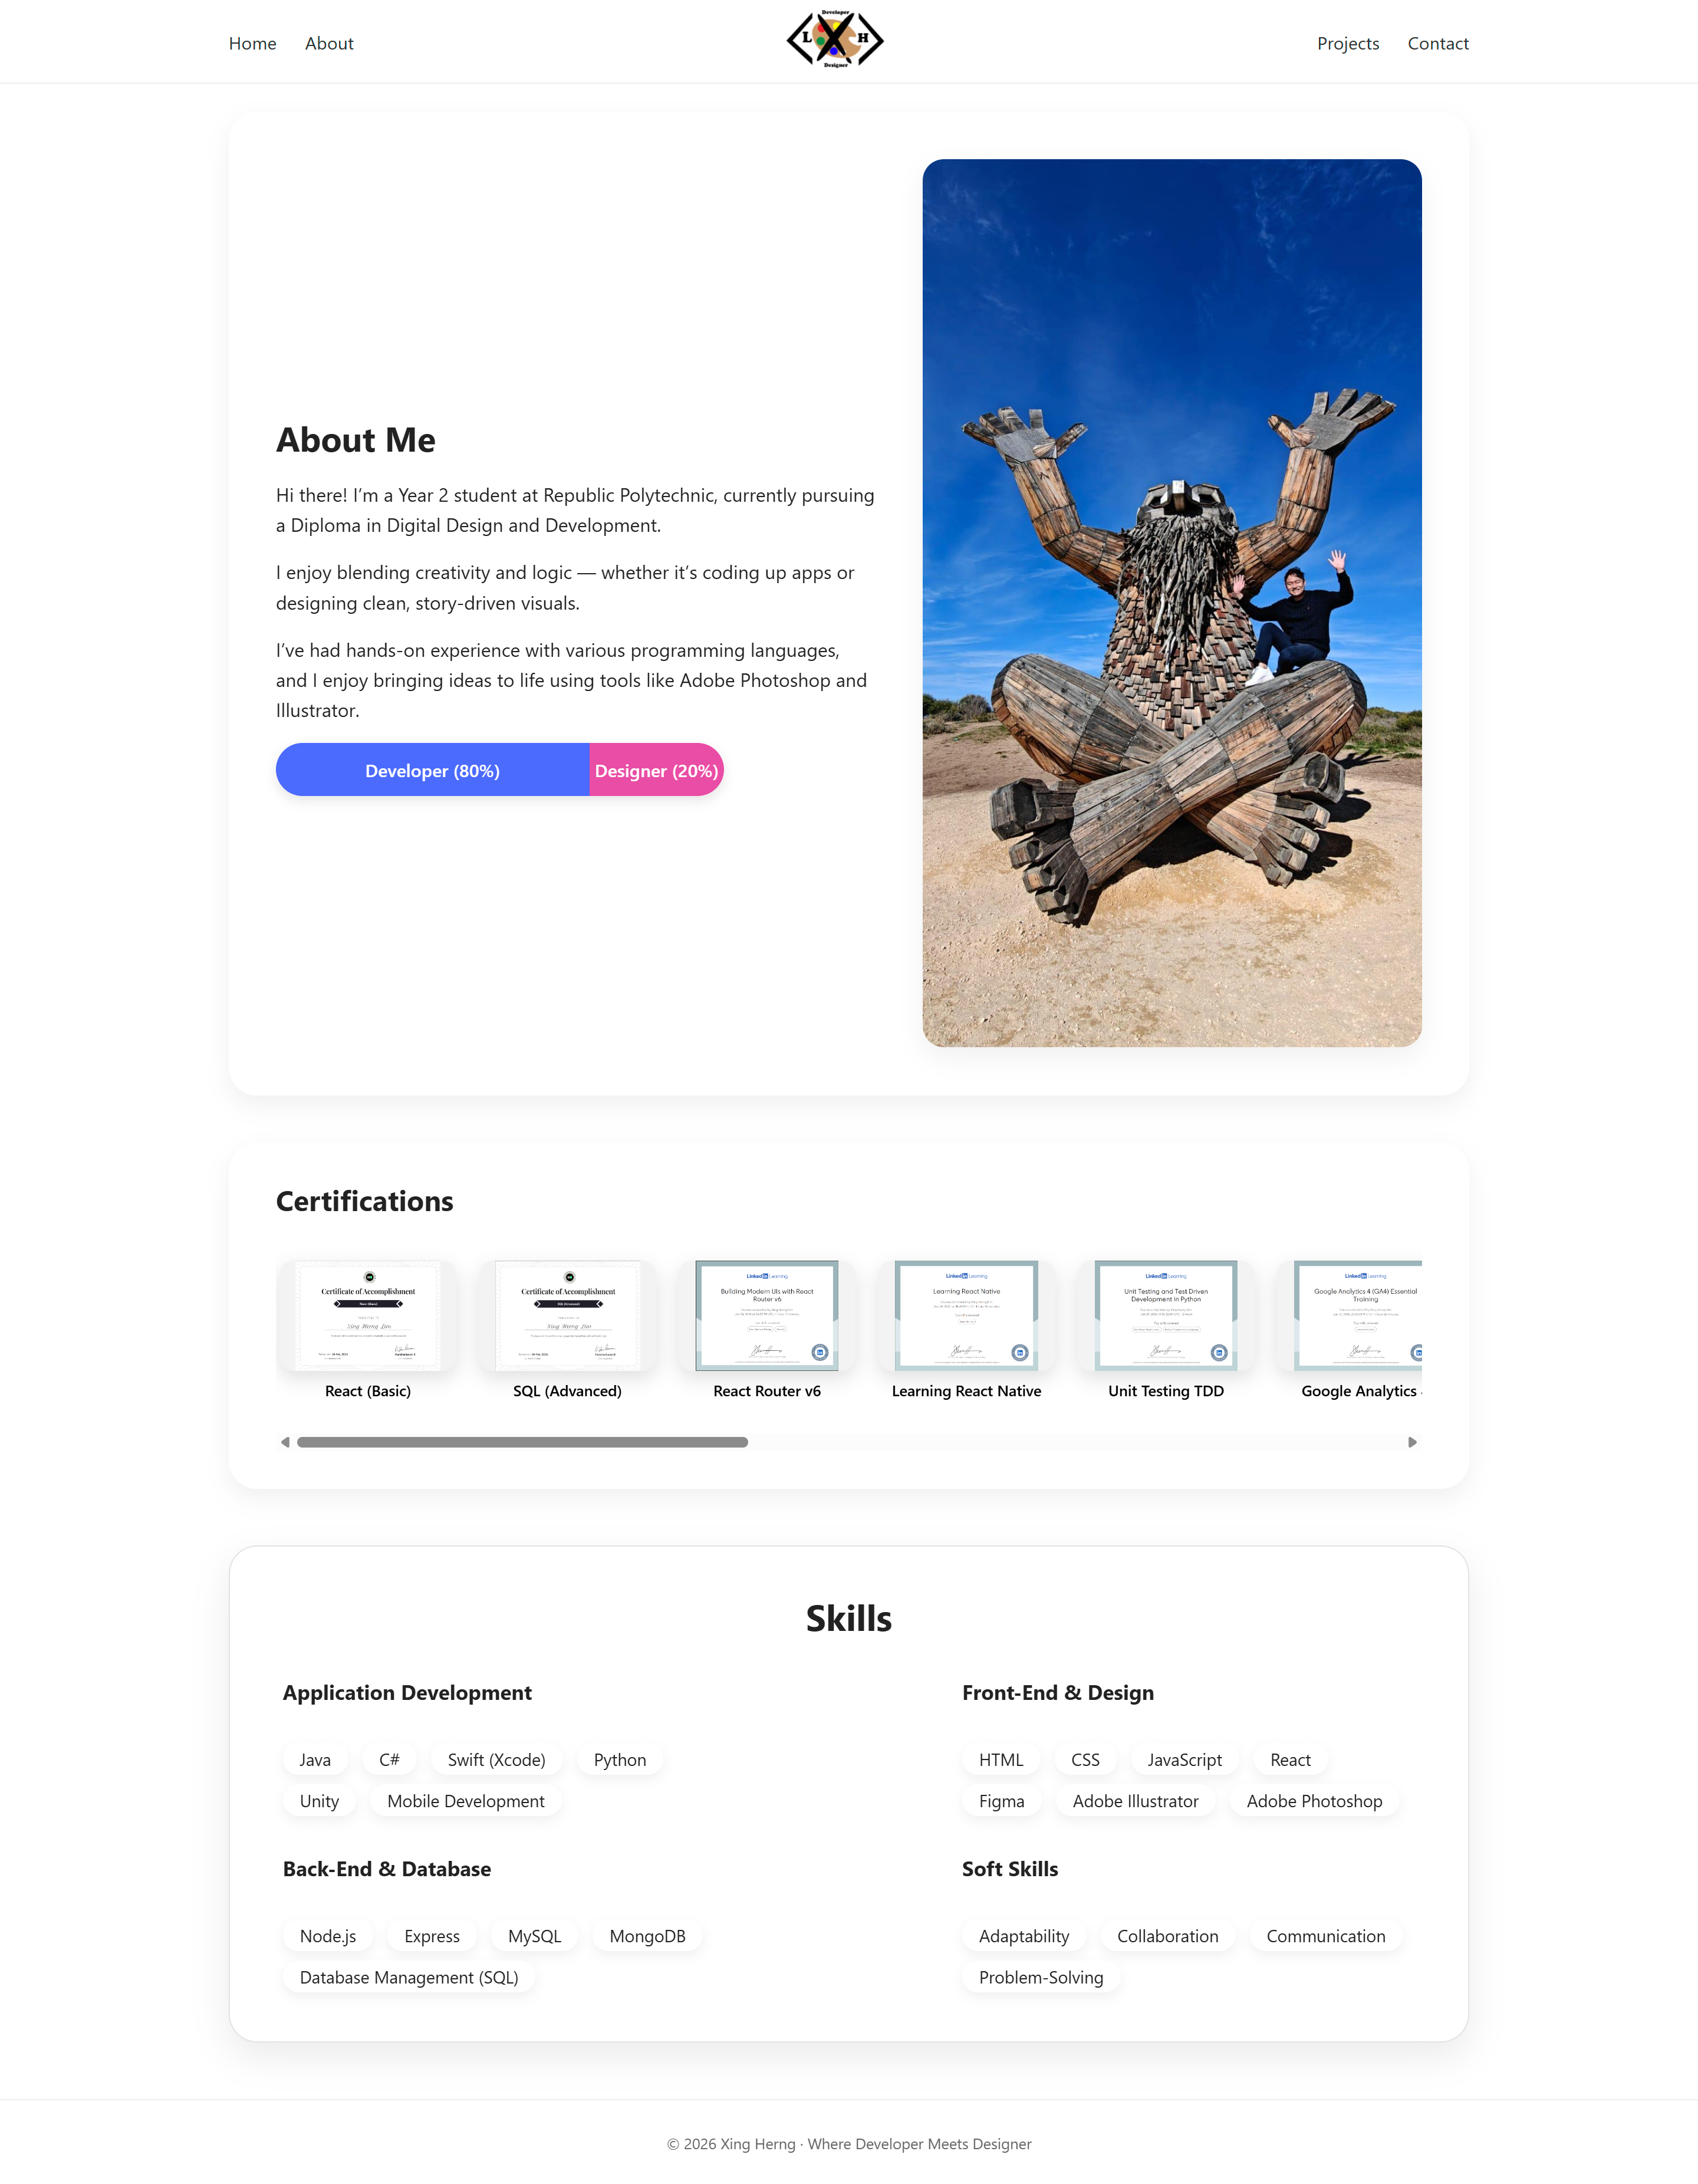

**Project Page:**

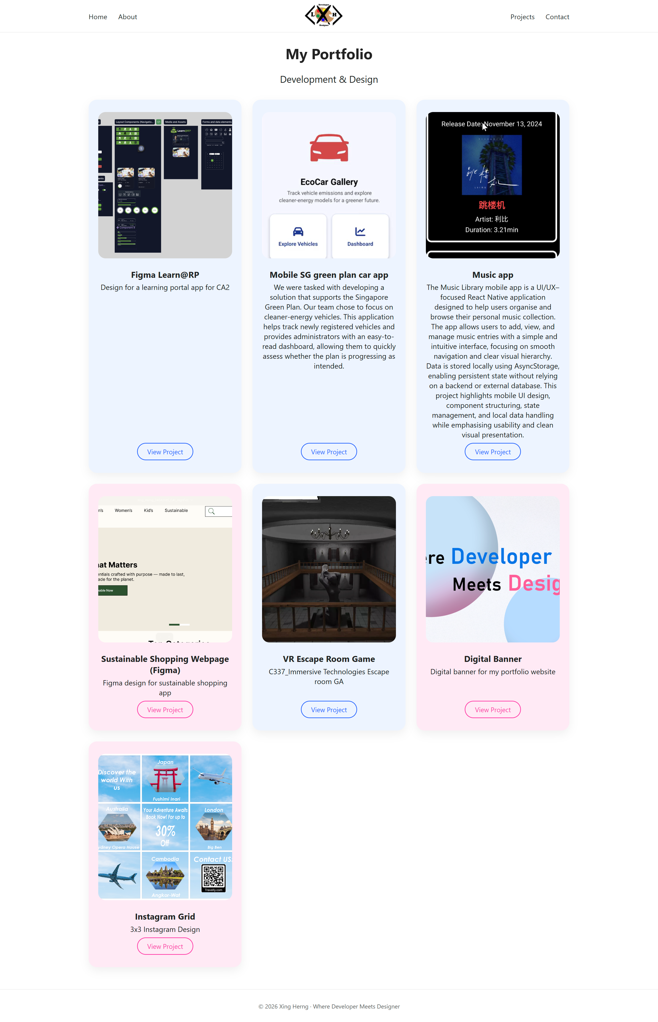

**Project Detail Page:**

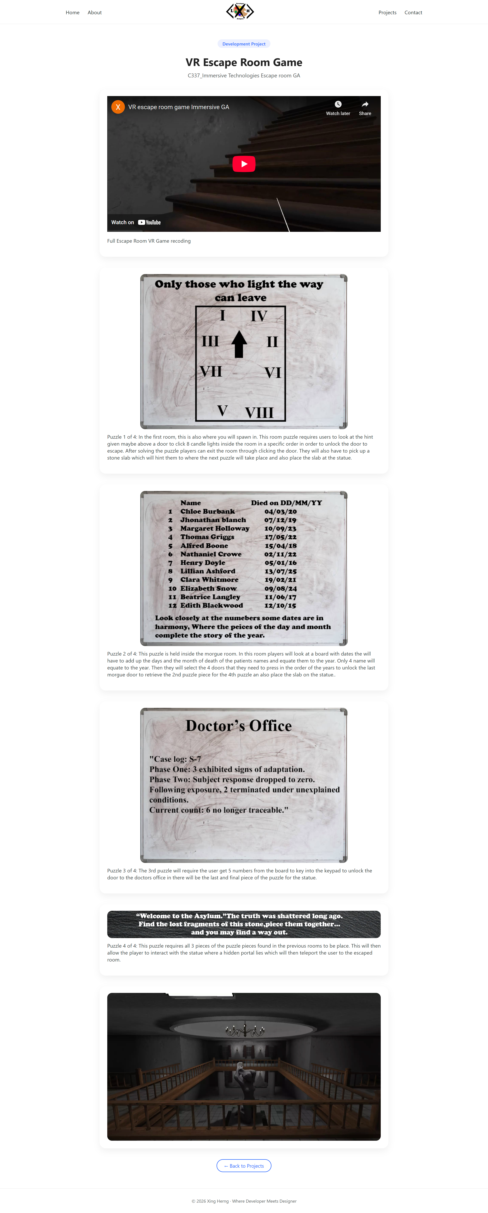

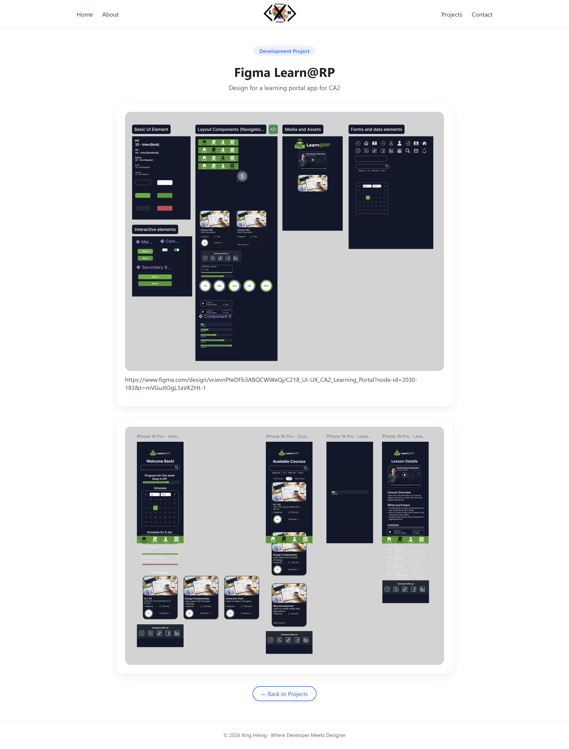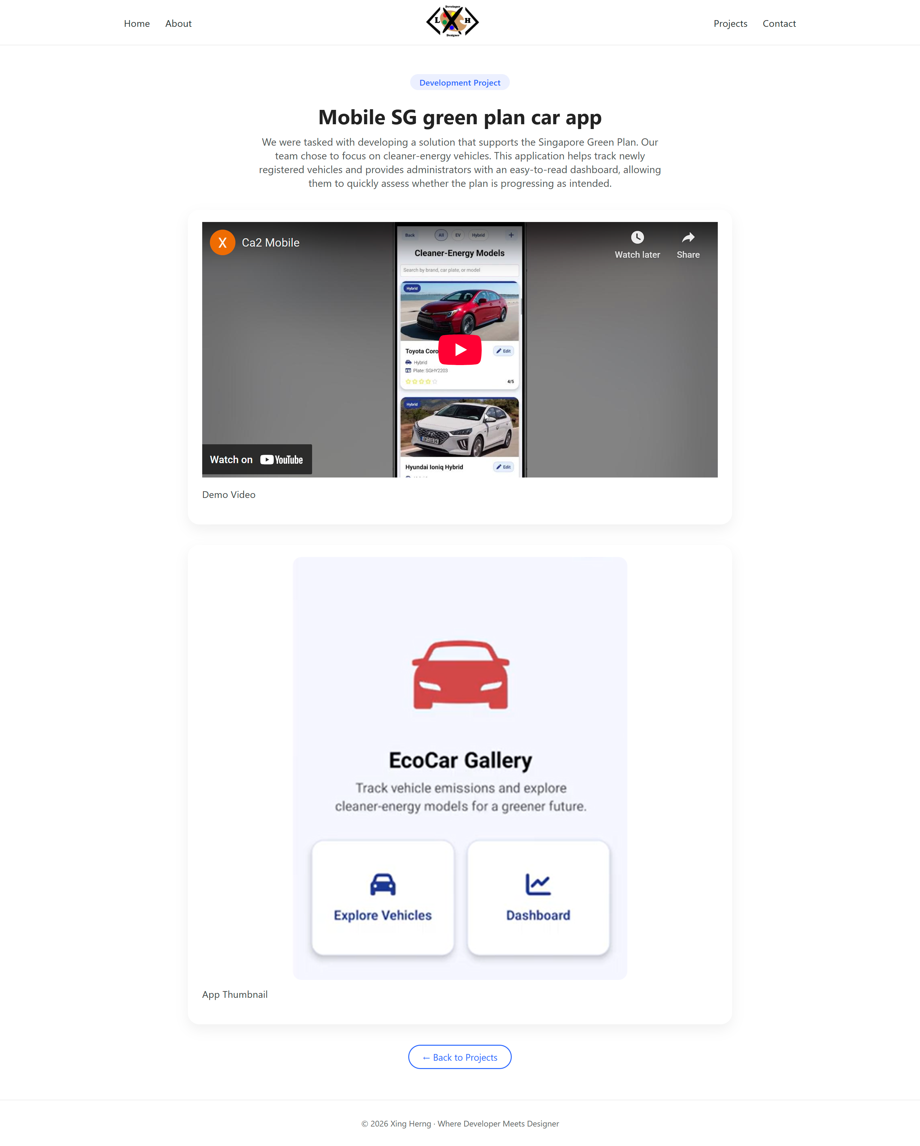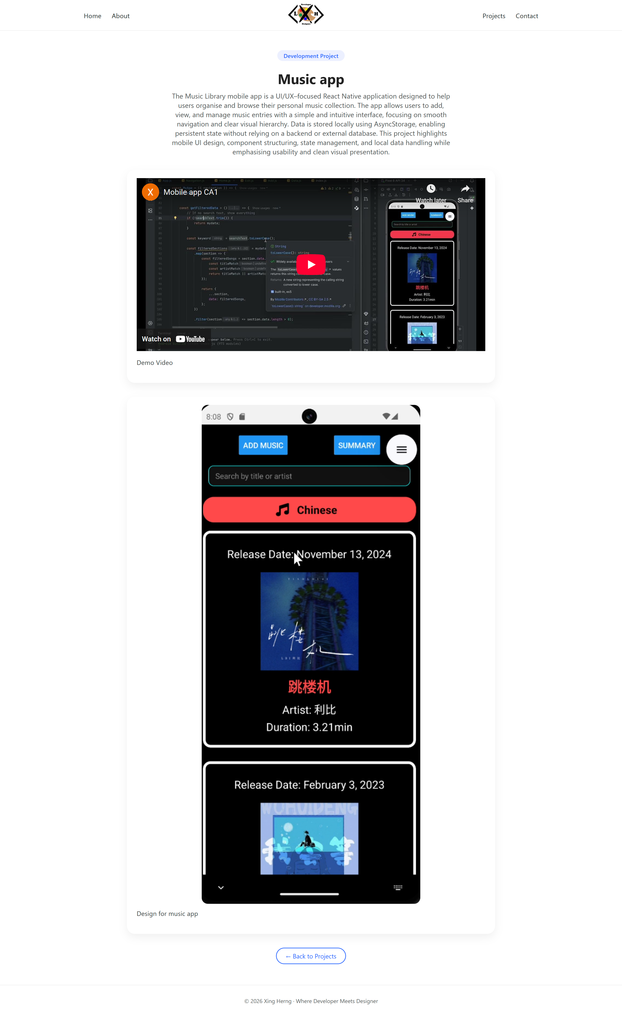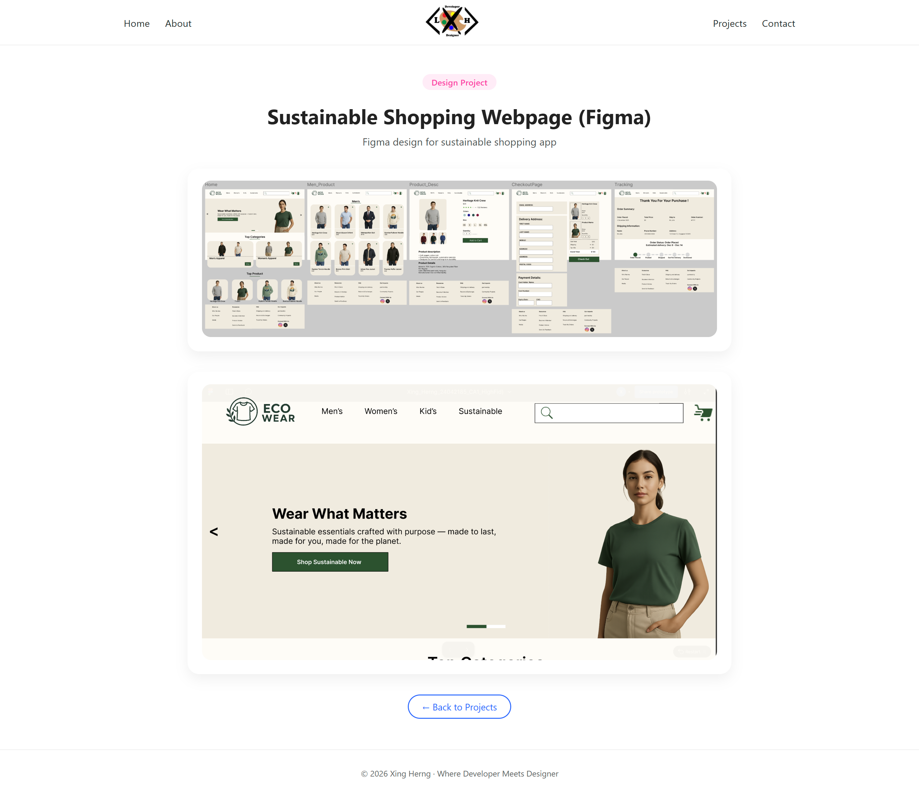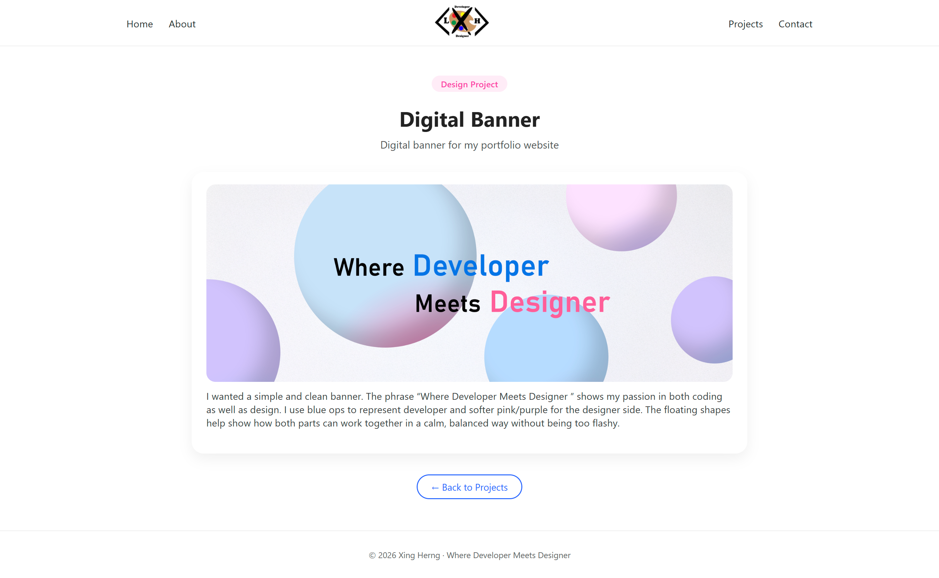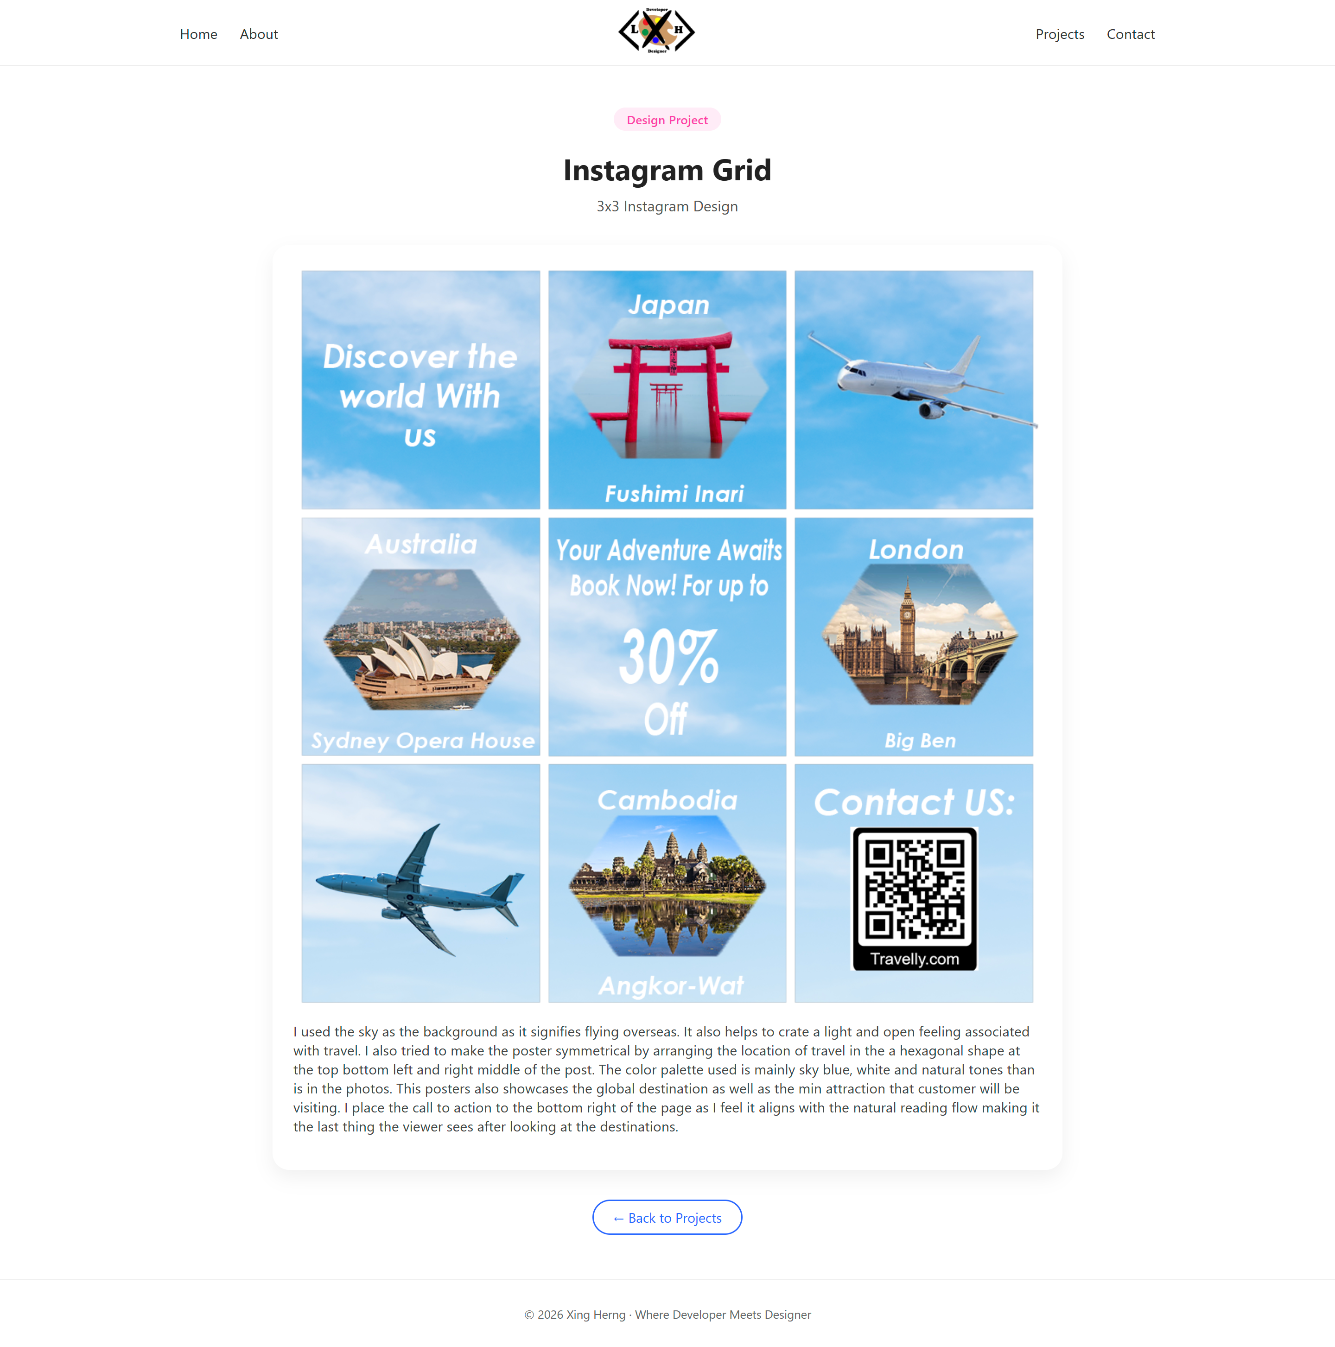

**Contact Me Page:  
